1. LDS manage data
2. Options > Update
3. Run Update

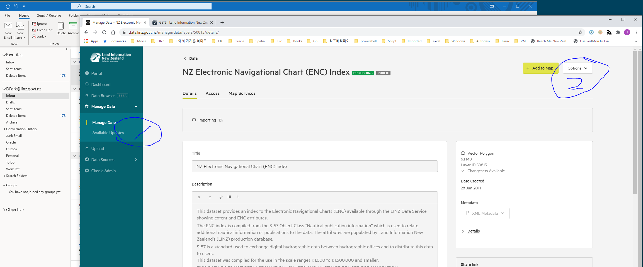

1. Jira for QC

